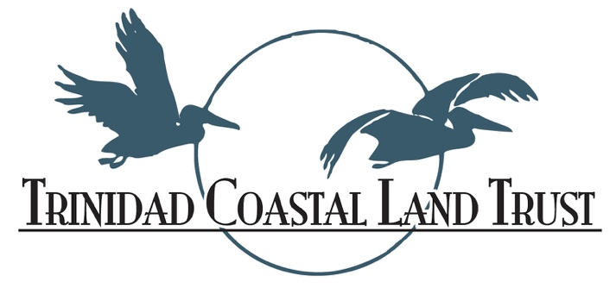
Yes! I want to be a Trinidad Coastal Land Trust Business Partner!

Our recognition opportunities let the community know that your business supports protecting our coast, while providing access for people to enjoy the area’s amazing beaches and vista points.

MY SUPPORT LEVEL IS:

- $250 Supporter – Your business logo linked on website, in our newsletter and listed as sponsor at our Annual “Toast to the Coast” Gala (in September).
- $500 Patron – Supporter benefits plus choice of being a Surf Cam (live video stream of the Camel Rock surf break) sponsor, or listed as a summer hike sponsor.
- $1000 Conservation Leader – All of the above, sponsorship plus 2 complimentary tickets to the Annual Toast to the Coast Gala.
- $2000+ Rock of Support – All of the above plus being both Surf Cam sponsor and a hike sponsor with business logo on event posters.

- Other (specify) _________________________________________________________________________________

We appreciate your generosity and support of the Trinidad Coastal Land Trust’s mission to provide coastal access while protecting the beauty and character of the Humboldt County coast from Little River to Big Lagoon.

You can also become a business partner online at: Trinidadcoastallandtrust.org

-------------------------------------------------------------------------------------------------------------
Contact Name ________________________________________________________________
Business Name _______________________________________________________________
Address: ____________________________ City, Zip ________________________________
Tel/Cell# ______________________Email Address: _________________________________
We will contact you to follow-up. Your donation is tax deductible. (Checks/credit cards and non-cash donations accepted.) Tax I.D. # 94-2552913
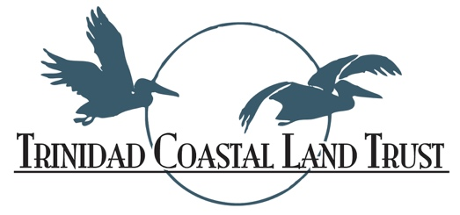
Providing coastal access while protecting the beauty and character beauty and character of the Humboldt County Coast from Little River to Big Lagoon.

We invite you to be a part of this important work by becoming a Business Partner. See the back side for sponsorship levels.

