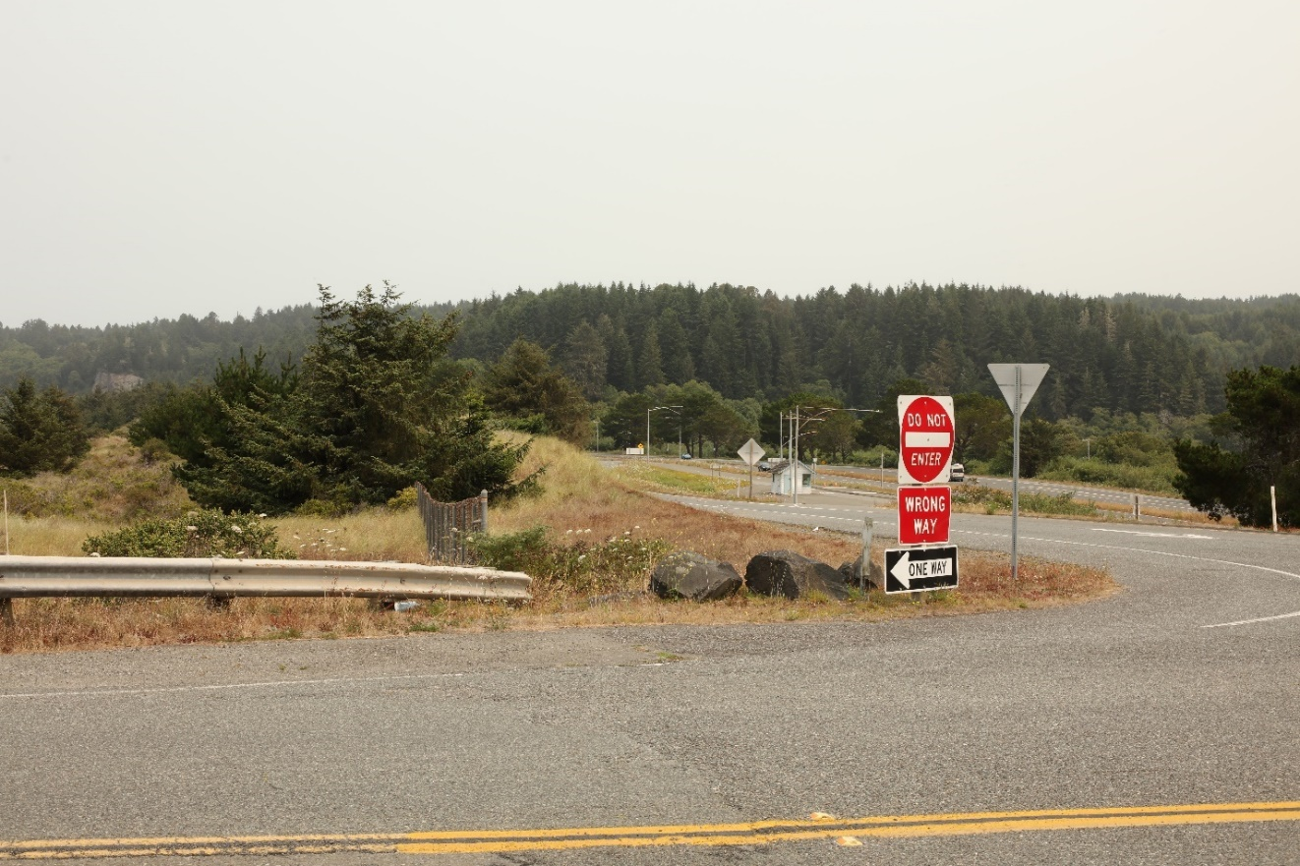

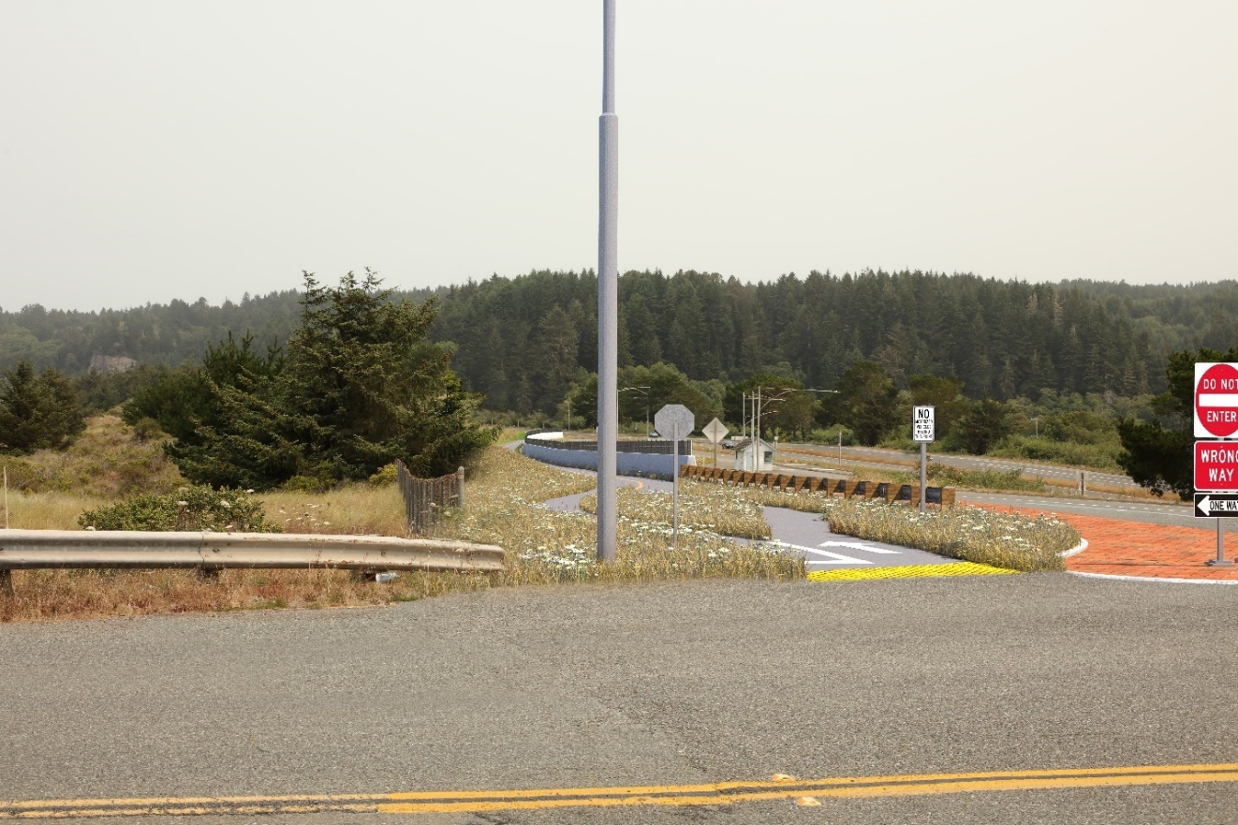
Figure 1: Key View 1 Existing View and Simulated Conditions. The view is to the north-northeast from the top of the US 101 off-ramp at Clam Beach Drive.

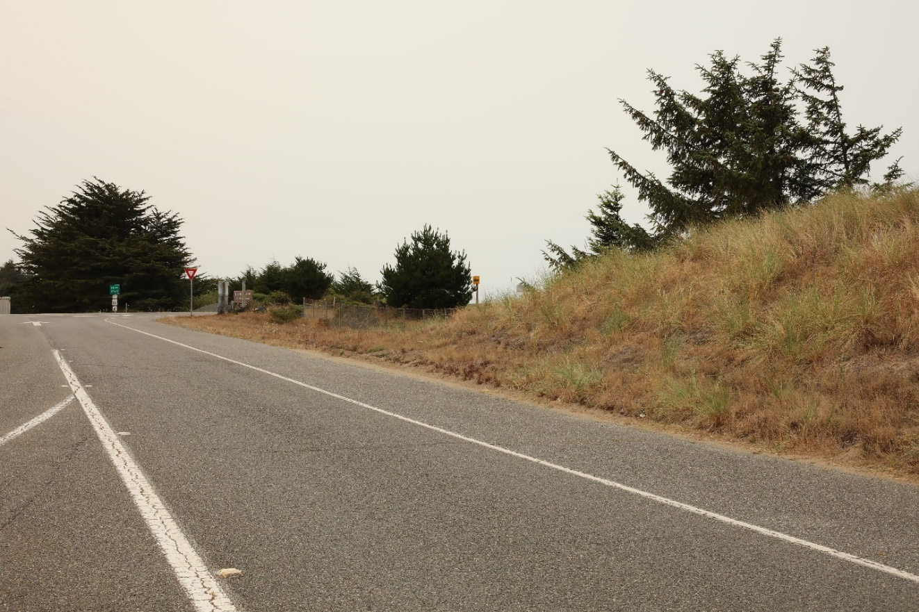

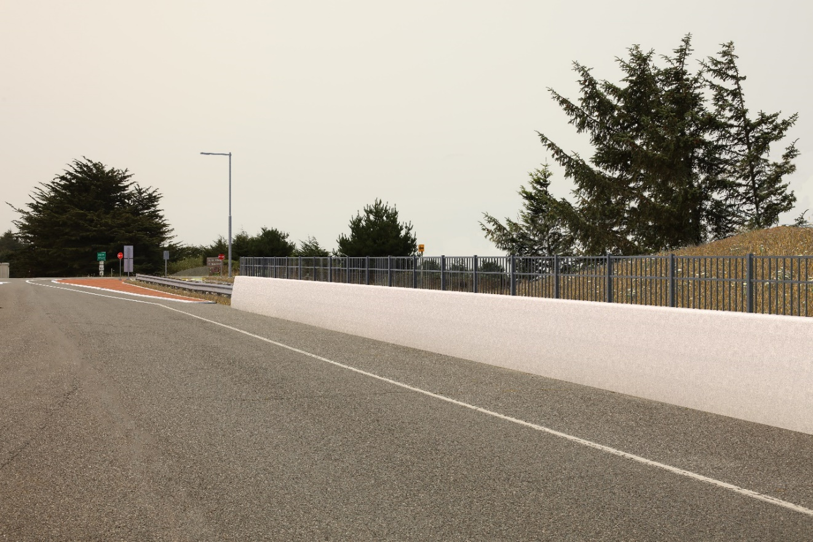
Figure 2: Key View 2 Existing View and Simulated Conditions. The view is to the southwest from the US 101 Clam Beach Drive off-ramp.

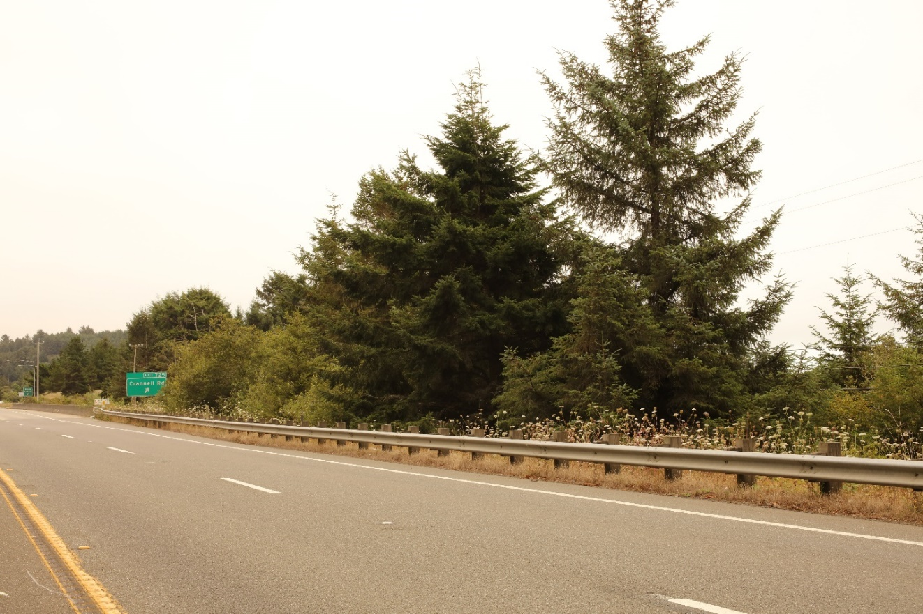

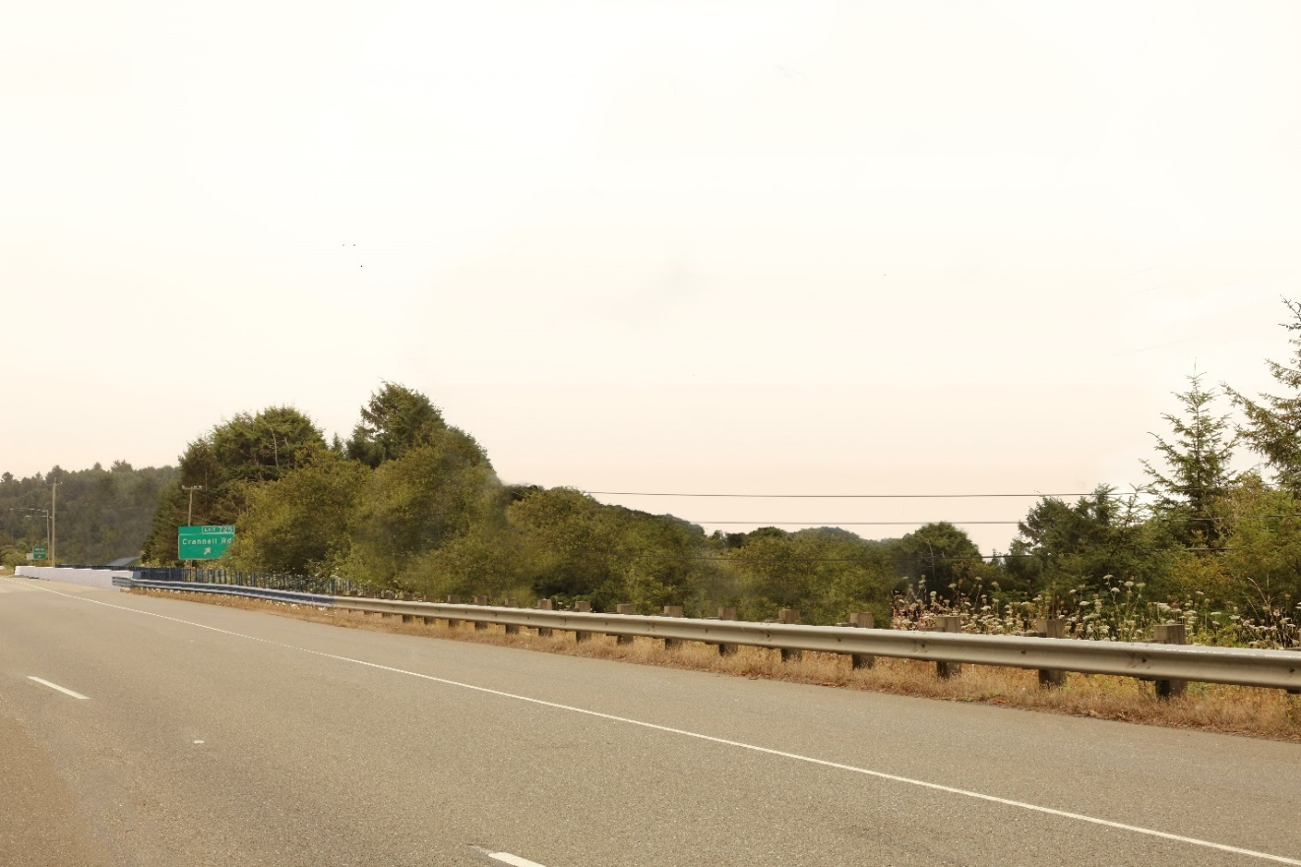
Figure 3: Key View 3 Existing View and Simulated Conditions. The view is to the south-southwest from the southbound lane of US 101, just north of the Little River Bridge.

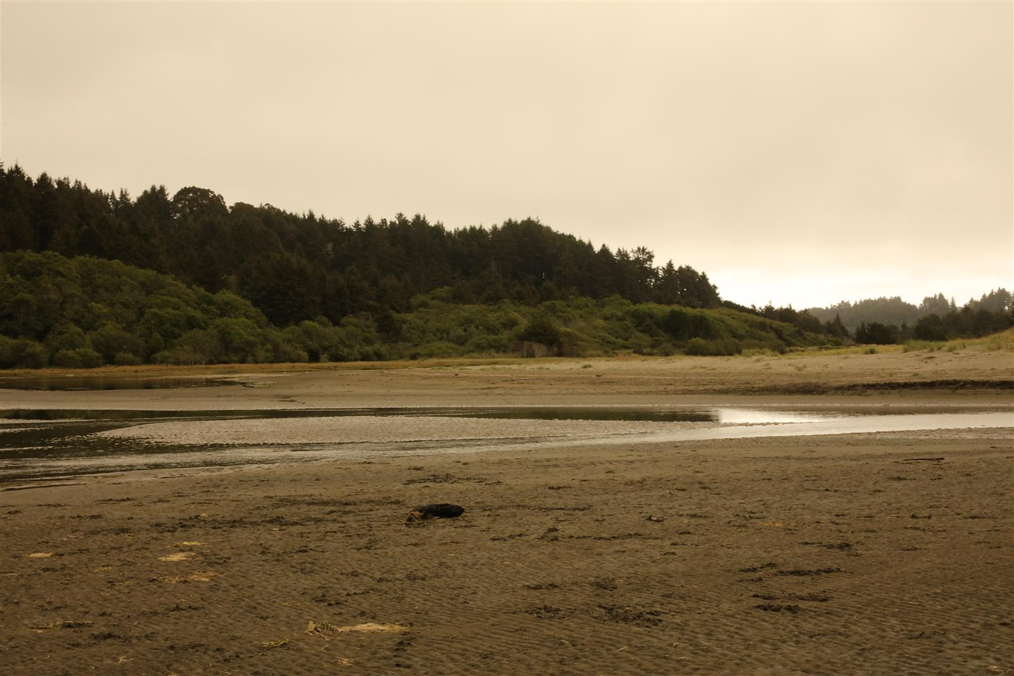
Figure 4. Character view looking east toward the project area. As such, the visual character and quality of the proposed project would be similar to the existing visual character and quality of the project area in its current state.

